
MTronic XT Traction Elevator Controller

Installation and Maintenance Manual
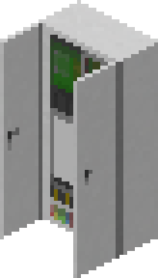
Table of Contents
Introduction 3
Installation Checklist 4
About the Controller 5
About the Dispatcher 6
Installation 7
Placing the controller and drive 7
Placing the car in the hoistway 8
Placing the machine 9
Placing the doors 10
Placing the dispatcher (group operation only) 11
Selecting simplex or group operating mode 12
Configuring the controller floor table (simplex operation only) 13
Configuring the dispatcher floor table (group operation only) 15
Connecting to the controllers (group operation only) 18
Testing the floor stops 20
Pairing the PIs and lanterns to the controller 21
Pairing the call buttons 22
Pairing the fire recall keyswitch 23
Controller Interface 24
Car Status 24
Fault History 27
Edit Parameters 28
Dispatcher Interface 29
Group Display 29
Main Menu 31
Controller Messages 32

Introduction
Thank you for selecting the MTronic XT traction elevator controller system! This is the most advanced elevator controller available in Minetest today.

This manual will help you understand, install, and configure your new elevator system. After installation, keep this manual with the controller in the event that it is needed for future reference, such as troubleshooting or configuration changes.

If you are an experienced user, following the installation checklist on the next page may be the fastest way to complete the installation. If you are not, or if you need assistance with any of the steps mentioned, continue reading and each step will be explained in detail.

Installation Checklist
□ Place controller and drive
□ Place car level with bottom floor
□ Place machine above car, above highest floor
□ Place doors
□ Pair machine with controller
□ (Group operation) Place dispatcher
□ Select group mode at controller
□ Enter floor table at controller (simplex) or dispatcher (group)
□ (Group operation) Connect dispatcher to controllers and set floors served
□ Test floor stops
□ Place PIs and lanterns and pair to controller
□ Place call buttons and pair to controller (simplex) or dispatcher (group)
□ (Group operation) Place swing call buttons and pair to controller (optional)
□ Place fire recall keyswitch and pair to controller (simplex) or dispatcher (group)

About the Controller
The MTronic XT controller is a traction elevator controller with the following features:
- 2 to 100 landings
- Total rise from 3 to 490 meters
- Speed from 0.2 to 20 meters/second
- Selective-collective operation
- Simplex or group (when connected to dispatcher) configurations
- Fire service
- Independent service
- Machine room and car-top inspection operation
- Swing operation
- Graphical configuration menus
- Easy setup wizard
- Touchscreen status display

As shipped, the controller is fully preassembled and prewired. The only actions needed before normal operation can begin are the connection of external devices and entry of parameters.

About the Dispatcher
The MTronic XT dispatcher connects to two or more MTronic XT controllers to enable group operation. It supports the following features:
- Group size from 2 to 16 cars
- True ETA-based dispatching algorithm
- Group recall for fire service
- Automatic reassignment of calls from busy/out of service cars
- Homogeneous or heterogeneous groups (not all cars have to serve all floors)
- Automatic configuration of controller floor tables from dispatcher settings
- Unlimited number of hall call risers
- Swing hall call risers for no, some, or all cars

Like the controller, the dispatcher is also shipped preassembled and prewired. The only actions needed are to enter the necessary parameters, connect the controllers for each car in the group, and connect any external devices needed.

Installation

Placing the controller and drive
The controller should be placed on the machine room floor in a location that provides access to its front for installation and service.

Please observe the following when selecting a location:
- Allow adequate space above and next to the controller. The cabinet is 2m tall and 1m wide, and the drive will occupy space to the right of the cabinet near the top.
- Allow space in front of the controller for access during installation and service. While the controller doors do not protrude past 1m even when open, placing objects in front of the controller may make service difficult. Leaving an empty, accessible space of at least 2m (measured with doors closed) in front of the controller is recommended.
- The machine room door should be of a type that locks. The controller cabinet is lockable (following area protection), however if it is accidentally left open, then anyone gaining access to the machine room will be able to modify parameters or change operating modes.

Place the controller and drive as shown here:
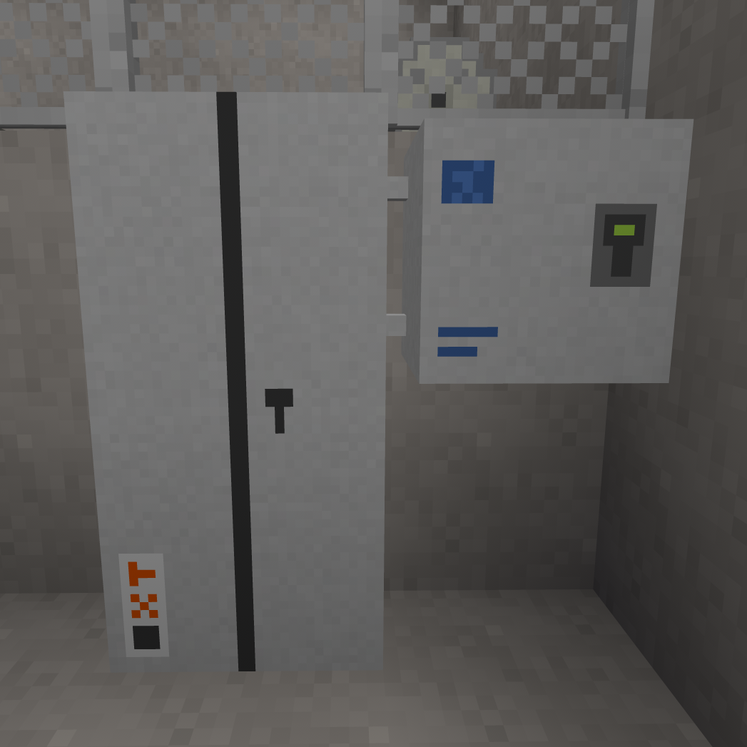

Placing the car in the hoistway
In order to be suitable for use, the hoistway must be 2m wide (side to side) and 3m deep (front to back). Any material may be used for its construction. The total height may be any desired value, however it must not be more than approximately 490m tall in total.
Doorways should be located on a narrow (2m wide) side of the hoistway. Each doorway should be 2m wide and 3m tall. They may be at any desired vertical spacing from each other, so long as they do not overlap.
At the bottom of the hoistway, leave at least 1m of extra height below the floor level of the lowest landing in order to accommodate the car floor and toe guard.
At the top, leave at least 2m of extra height (3m recommended) in order to have adequate headroom when operating the car on car top inspection mode.
Place the car in the hoistway at the lowest landing. When placing the car, face into the hoistway and point at the left wall, just inside the door, at the level of the lowest portion of the door, as shown:
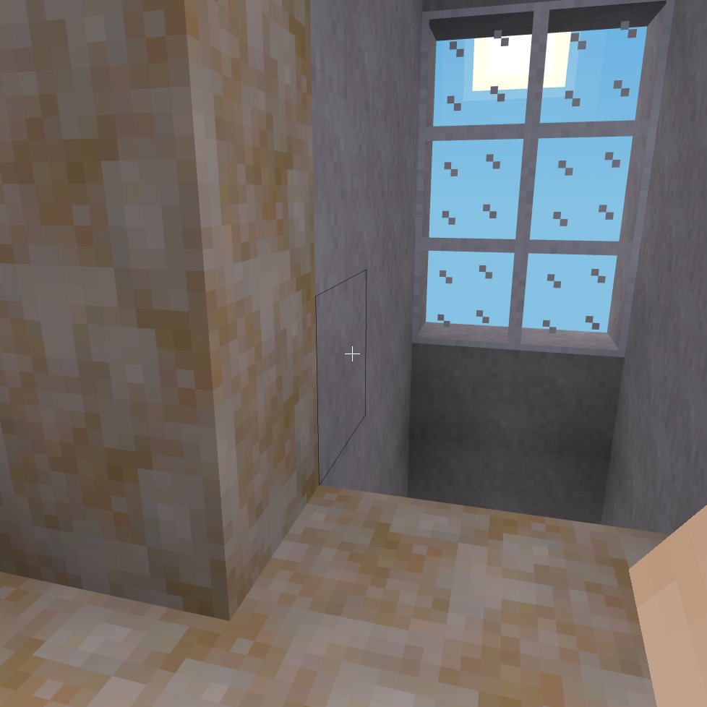
If you need to remove the car, hold the sneak key (by default, the shift key) and punch (left-click by default) the panel of key switches in the bottom left.

Placing the machine
Place the machine directly above the top of the hoistway. The placement location must be directly above some part of the car, with a gap of no more than 500 meters.
When the machine is placed, the motor and brake will be automatically placed to the left of the machine, and the traction sheave will face towards you.
Recommended placement of the hoist machine (steel and grating is directly above the car):
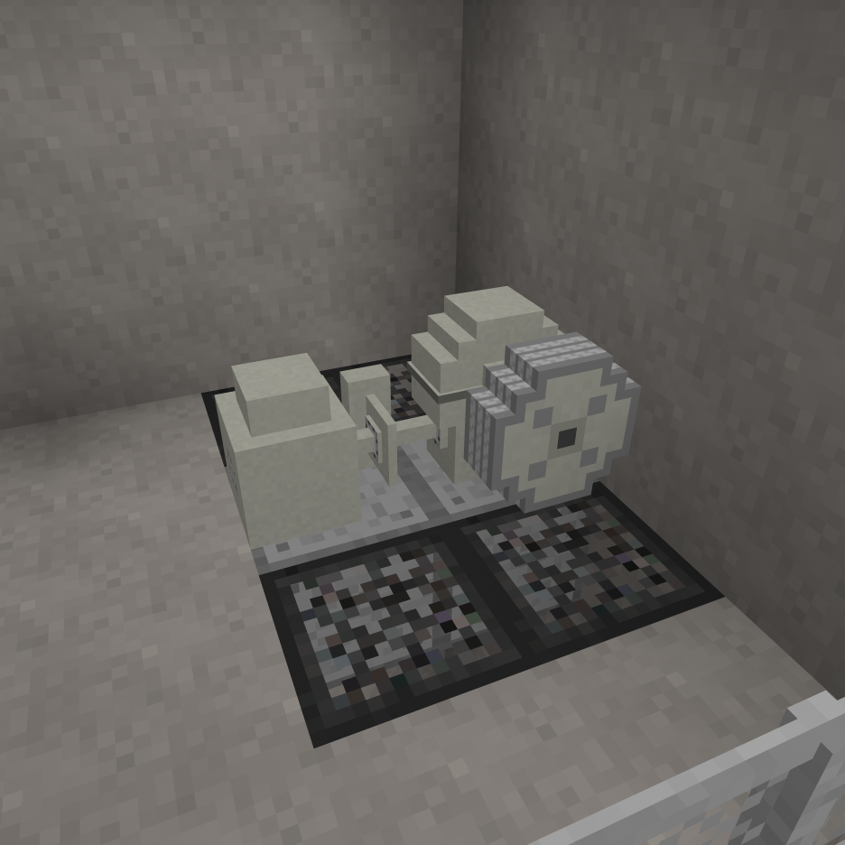
After placement, open the form on the machine (right-click by default) and enter the ID number of the controller it will be used with. The ID number can be obtained by pointing at the controller.
Next, verify that the text shown when pointing at the machine indicates the coordinates of the car. If it states that no car was found, make the necessary adjustments and punch (left-click by default) the machine to try again.

Placing the doors
Place a set of hoistway doors at each floor that will be served, including the floor the car was placed at. The car is equipped with a door restrictor, so if the car attempts to stop at a floor that is missing hoistway doors, the car doors will remain closed and the controller will report a fault and shut down.
Car doors are provided with the car and do not need to be placed manually.
To place the doors, point at the left side of the floor in the doorway, as shown:
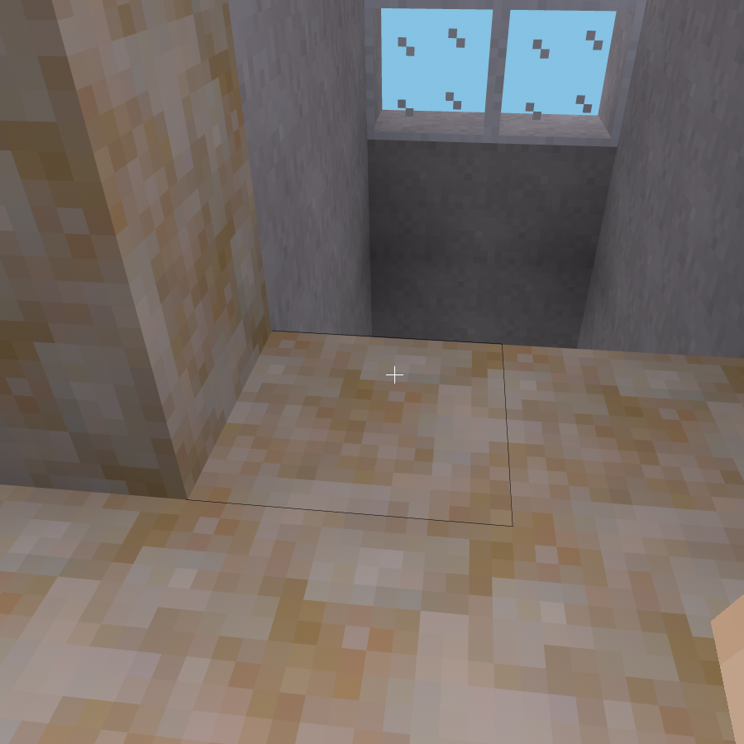
If you later need to remove a set of doors, dig the lower left corner as viewed from outside.

Placing the dispatcher (group operation only)
A dispatcher is only needed for group (more than one car) operation. Skip this step if you will be using simplex (single car) operation.
The dispatcher should be placed on the machine room floor in a location that provides access to its front for installation and service.
Please observe the following when selecting a location:
- Allow adequate space above and next to the dispatcher. The cabinet is 2m tall and 1m wide.
- Allow space in front of the dispatcher for access during installation and service. While the dispatcher doors do not protrude past 1m even when open, placing objects in front of the dispatcher may make service difficult. Leaving an empty, accessible space of at least 2m (measured with doors closed) in front of the dispatcher is recommended.
- The machine room door should be of a type that locks. The dispatcher cabinet is lockable (following area protection), however if it is accidentally left open, then anyone gaining access to the machine room will be able to modify parameters.
Place the dispatcher as shown:
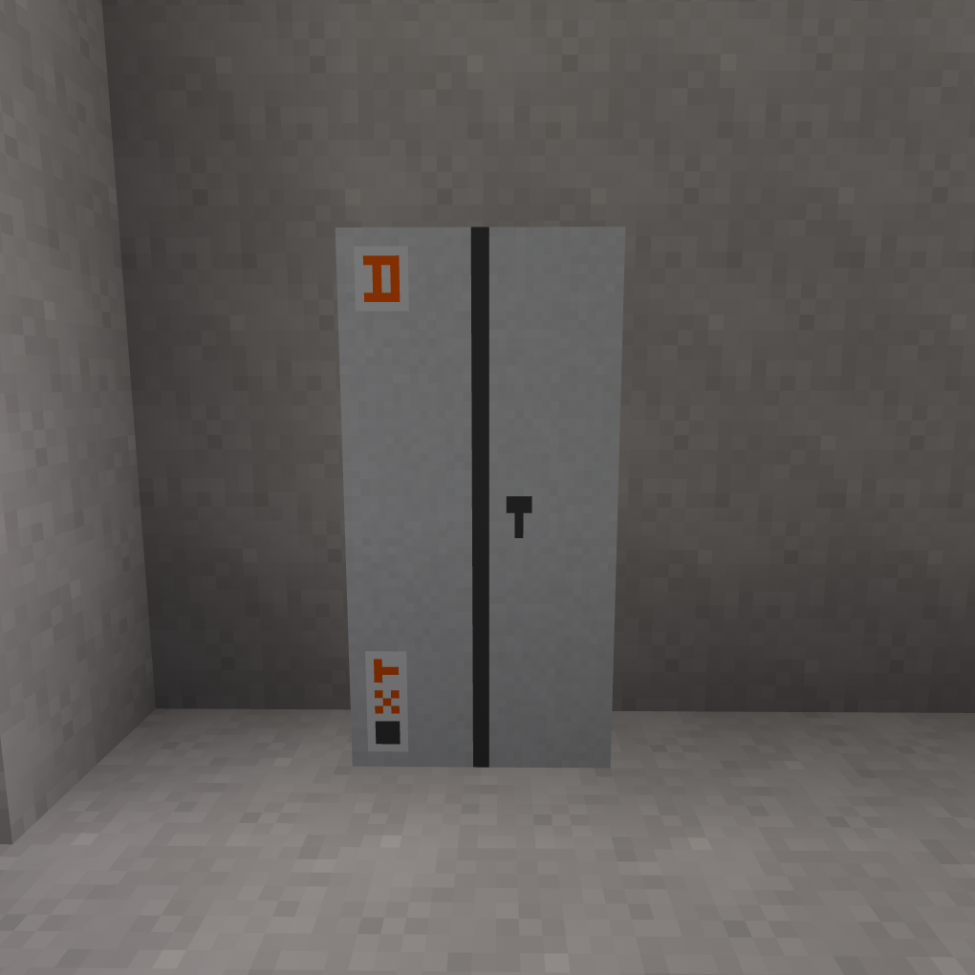

Selecting simplex or group operating mode
Punch (left-click by default) the controller cabinet to open the door, then open (right-click by default) the controller display.
The following screen should appear:
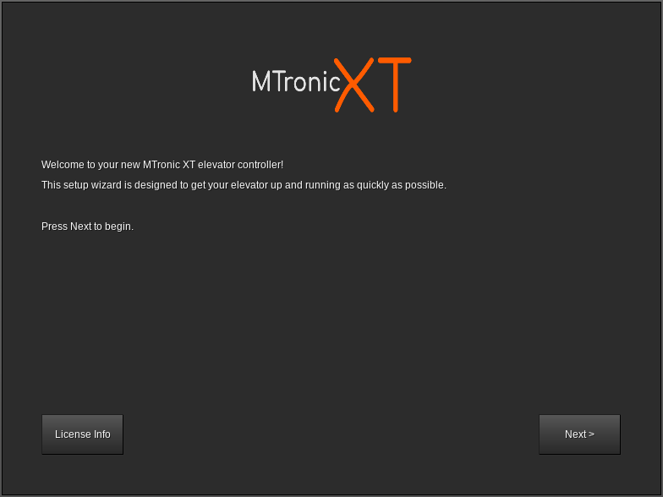
Click Next. The screen should change to the following:
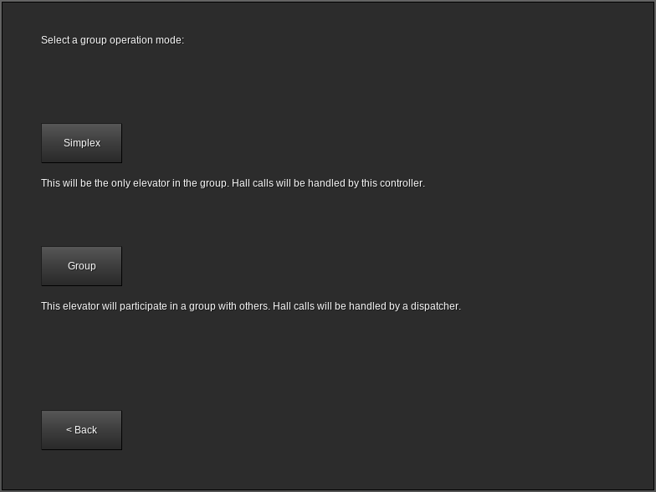
If this car will be operating in a simplex configuration (meaning this is the only car), click Simplex. If this car will operate in a group (multiple cars), click Group.

Configuring the controller floor table (simplex operation only)
Cars using group operation have the floor table sent by the dispatcher. This section is only applicable to simplex cars.
After clicking Simplex at the group mode selection screen, the floor table editor will appear:
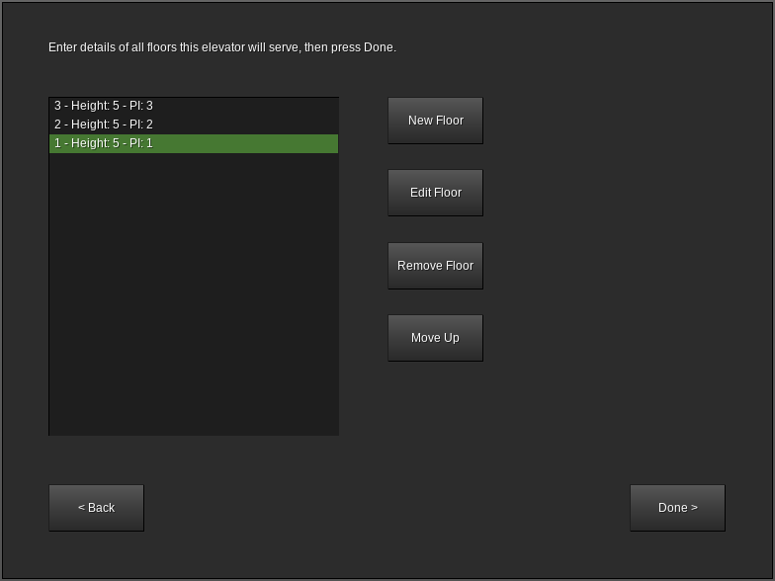
The list at the left shows each floor the elevator will serve. By default, three floors are present, each 5 meters tall, numbered from 1 to 3.
The number on the far left of each line (to the left of Height) is the landing number. This always starts at 1 for the lowest landing and increases by 1 with each landing upwards.
Height indicates the distance from floor level at this floor to floor level at the next floor (not applicable at the top floor). For example, if standing on floor 1 shows your height as +10.5 and standing on floor 2 shows your height as +15.5, then the height of floor 1 is 5. For the topmost floor, the height value is unimportant and any number can be entered.
PI is the text that will be used when displaying this floor, as well as the text that will be on the button for this floor. For example, if landing 1 has PI set to L, then when the car is at landing 1, the position indicator(s) will show L. This value can be one to three characters long and can contain any printable ASCII characters, including uppercase and lowercase letters, numbers, symbols, and spaces. For best results, use numbers and uppercase letters.
New Floor adds an extra floor to the top of the list. You can create up to 100 floors.
Remove Floor removes the highlighted floor from the list and renumbers the remaining floors appropriately. You can only remove a floor if you have at least three floors.
Move Up and Move Down move the highlighted floor up or down in the list. These buttons only appear if the highlighted floor is not already at the respective end of the list.
Edit Floor opens the floor editor:
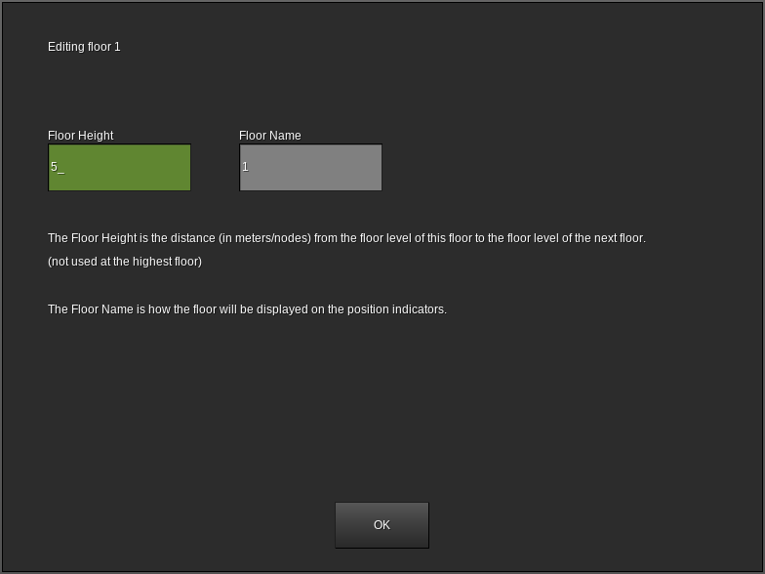
Floor Height sets the height of this floor (see Height on the previous page).
Floor Name sets the name of this floor (see PI on the previous page).
When the values are correct, click OK to return to the previous floor table editor screen.
When the floor table is complete and accurate, click Done to save your changes.

Configuring the dispatcher floor table (group operation only)
Cars using group operation have the floor table created at the controller. This section is only applicable to cars using group operation.
Punch (left-click by default) the dispatcher to open the door, then open (right-click by default) the form. The following screen should appear:
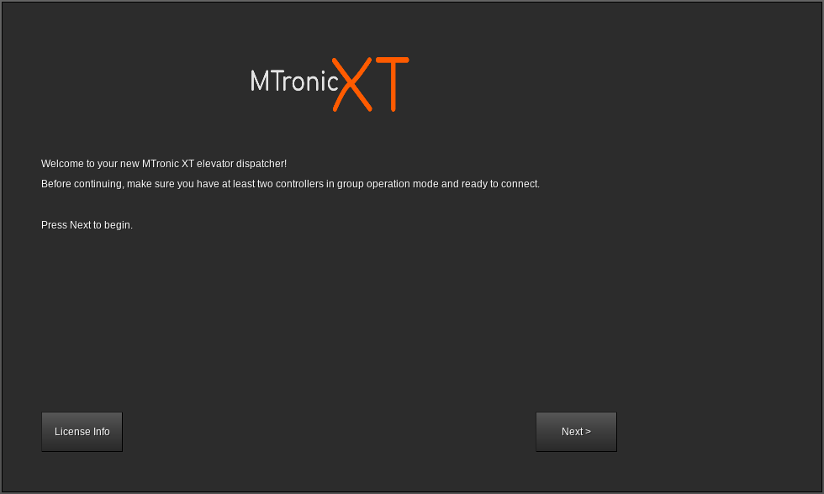
Click Next. The floor table editor will appear:
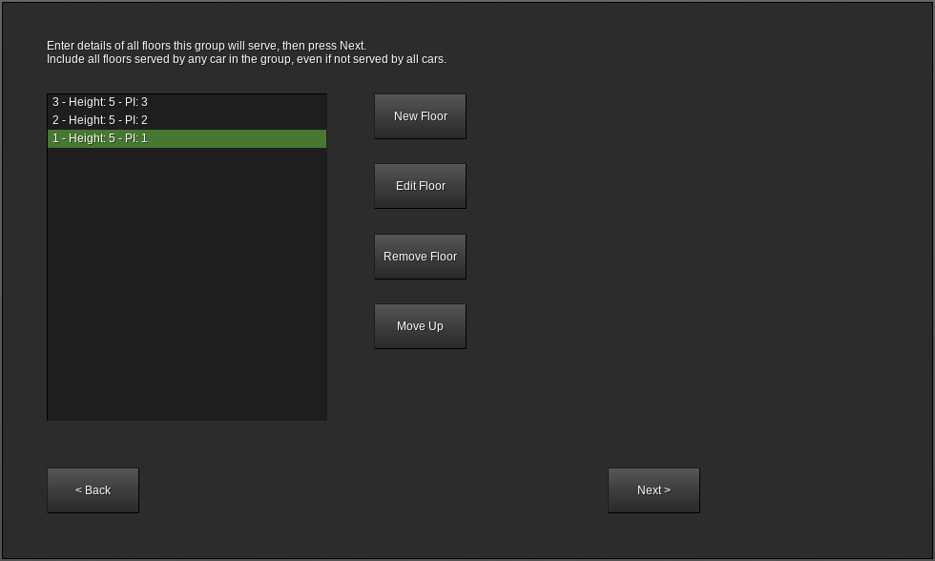
The list at the left shows each floor the elevator will serve. By default, three floors are present, each 5 meters tall, numbered from 1 to 3.
The number on the far left of each line (to the left of Height) is the landing number. This always starts at 1 for the lowest landing and increases by 1 with each landing upwards.
Height indicates the distance from floor level at this floor to floor level at the next floor (not applicable at the top floor). For example, if standing on floor 1 shows your height as +10.5 and standing on floor 2 shows your height as +15.5, then the height of floor 1 is 5. For the topmost floor, the height value is unimportant and any number can be entered.
PI is the text that will be used when displaying this floor, as well as the text that will be on the button for this floor. For example, if landing 1 has PI set to L, then when the car is at landing 1, the position indicator(s) will show L. This value can be one to three characters long and can contain any printable ASCII characters, including uppercase and lowercase letters, numbers, symbols, and spaces. For best results, use numbers and uppercase letters.
New Floor adds an extra floor to the top of the list. You can create up to 100 floors.
Remove Floor removes the highlighted floor from the list and renumbers the remaining floors appropriately. You can only remove a floor if you have at least three floors.
Move Up and Move Down move the highlighted floor up or down in the list. These buttons only appear if the highlighted floor is not already at the respective end of the list.
Edit Floor opens the floor editor (see next page).
Floor Height sets the height of this floor (see Height on the previous page).
Floor Name sets the name of this floor (see PI on the previous page).
When the values are correct, click OK to return to the previous floor table editor screen.
Note that all floors served by any car in the group must be entered, even if not all cars in the group will serve all floors. You will have an opportunity in the next step to choose which floors are served by each car.
When the floor table is complete and accurate, click Next to save your changes.

Connecting to the controllers (group operation only)
Simplex cars do not have a dispatcher. This section is applicable to cars using group operation only.
After the floor table has been saved, the following screen should appear:
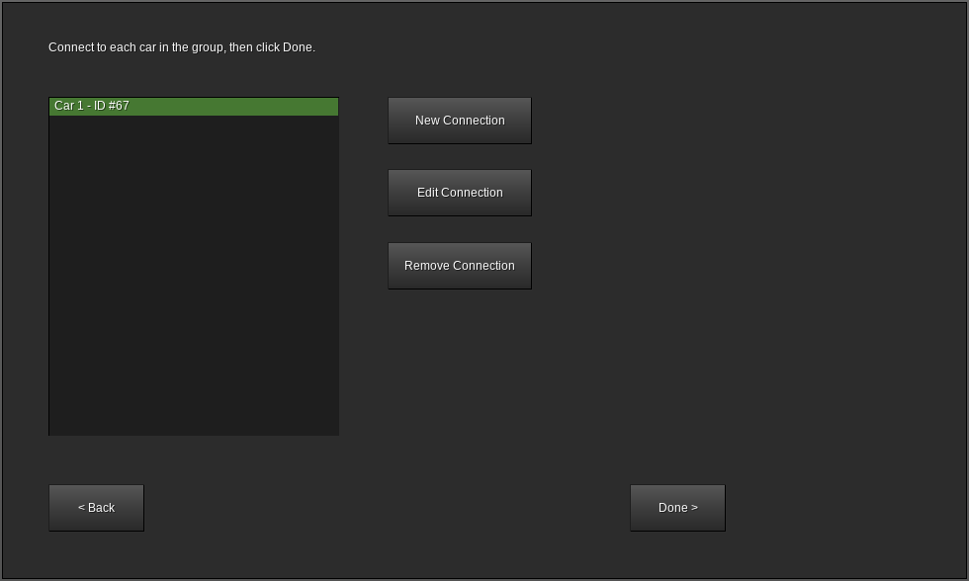
This screen lists all of the current connections from this dispatcher to the controllers of the cars in its group.
ID is the ID number of the controller. This can be obtained by pointing at the controller.
Remove Connection removes the highlighted car from the group.
New Connection adds a new car to the group.
Edit Connection is used to change the floors served by the highlighted car.
Clicking New Connection or Edit Connection opens the following screen:
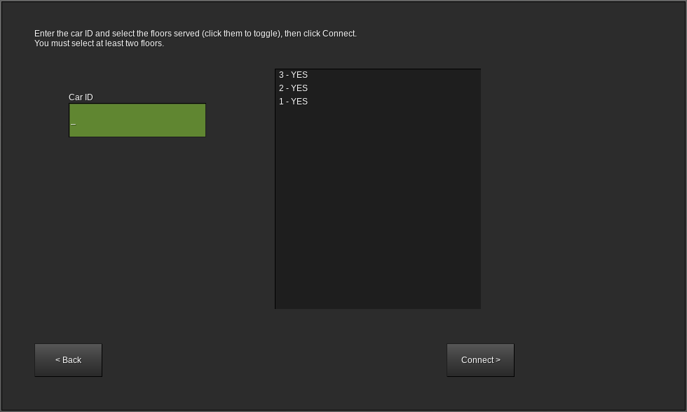
Car ID is the ID number of the controller to be added to the group. This can be obtained by pointing at the controller, or if the controller is ready to pair then the ID number will also be shown on the controller display.
The list on the right side controls which floors will be served by this car. This should show YES for floors that exist on this car and NO for floors which do not. Click a floor in the list to toggle it to YES or NO. At least two floors must be set to YES.
When the floor list is correct and the car ID has been entered, click Connect. If the connection was successful, the previous screen should reappear.
If the connection fails, check the following:
- Is the car ID correct? The controller should show its ID number on its display.
- Is the controller already in a group? Controllers can only be connected to if they have not already been connected.
- Is the controller ready to connect? The group mode should be set to Group and the controller display should show Waiting for connection from dispatcher...
When all controllers in the group are connected, click Done.

Testing the floor stops
Before continuing, set the TEST switch on the controller (located under the display) to the on position. This will disable all hall calls and prevent the doors from opening.
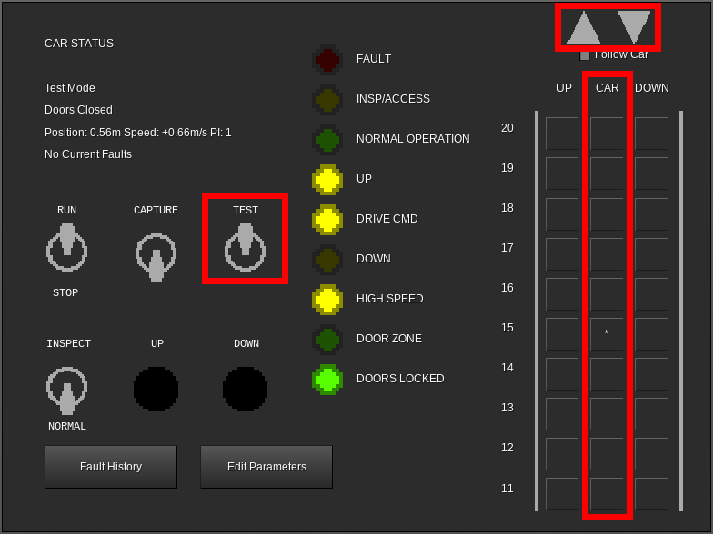
One at a time, click each floor in the CAR column. This will place a car call (indicated by an asterisk) on that floor. After placing each call, observe the car and verify that it stops properly at the floor, then continue on to the next floor. Due to test mode being enabled, the doors will not open when the car stops.
If the car serves more than ten floors, up and down arrow buttons will become available in the top right corner of the controller display. Use these to scroll the view up and down in order to place car calls above the 10th floor.
When satisfied with the performance, set the TEST mode switch to the off position. The green NORMAL OPERATION LED should light. The doors will now open in response to calls. If desired, the test may be repeated in this mode in order to verify proper door operation.

Pairing the PIs and lanterns to the controller
PIs (position indicators), lanterns, and PI/lantern combinations may be placed in any desired location.
A typical configuration is:
- Down lantern near the doorway on the topmost floor
- Up/down combination lanterns near the doorway on all intermediate floors
- Up lantern near the doorway on the bottommost floor
- PI/lantern combination in place of the lantern on the lobby floor
- PI in the building security office, if one exists
Any number of these items can be used per car.
After placing each item, open its form (right-click by default):
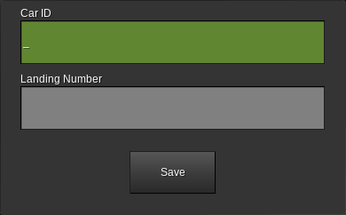
Car ID is the ID number of the controller that this device will be connected to. This can be obtained by pointing at the controller.
Landing Number is the number of the landing that this device is installed on. This comes from the leftmost number in the floor table, not the name of the floor. For example, the lowest floor is always “1”, the next lowest floor is always “2”, etc.
For cars using group operation, skip counting any floors this car does not serve. For example, if the group spans floors LL, G, and M, but this car only serves LL and M (and does not serve G), then if this device is on floor M, the landing number would be 2.
Not all device types will request a landing number.
When the values are correct, click Save.

Pairing the call buttons
Call buttons may be placed in any desired location. Typically, the topmost floor will have a down button, the bottommost floor will have an up button, and intermediate floors will have both up and down buttons.
For simplex cars:
Placement and pairing is identical to lanterns. See the previous page.
For cars using group operation:
Placement and pairing is identical to lanterns (see the previous page), except as follows:
- For normal call buttons, enter the ID of the dispatcher in the Car ID field. This can be obtained by pointing at the dispatcher.
- For swing call buttons (call buttons that will always call a specific car), enter the ID number of the associated controller in the Car ID field. This can be obtained by pointing at the controller.

Pairing the fire recall keyswitch
The fire recall keyswitch can be placed in any desired location, however it is typically located on the lobby floor and near the elevator or group of elevators.
Use only one of these keyswitches per car (simplex) or group (group).
After placing the switch, open its form (right-click by default):
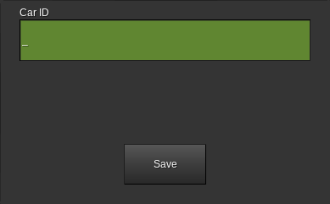
For simplex cars:
Enter the ID number of the controller. This can be obtained by pointing at the controller.
For cars using group operation:
Enter the ID number of the dispatcher. This can be obtained by pointing at the dispatcher.

Controller Interface

Car Status
This is the main screen that is normally displayed on the controller.
It is divided into five sections as follows:
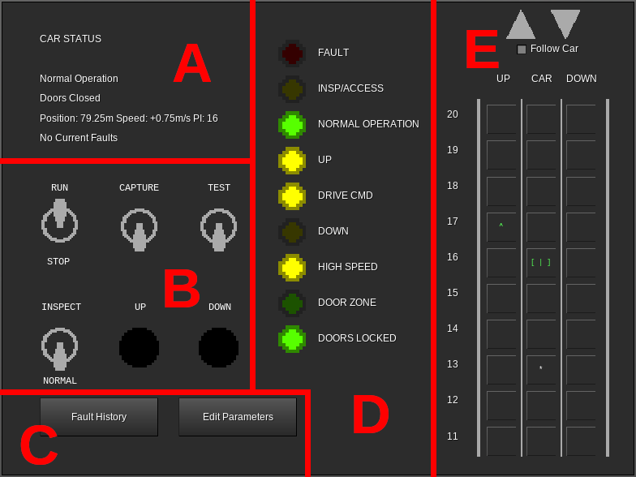
Section A (Status Display)
Line 1 of this section shows the current operation mode of the car. See the Controller Messages section on page 32 for information on possible values.
Line 2 of this section shows the current state of the doors (opening, open, closing, or closed).
Line 3 shows the position of the car in meters above the lowest floor, the speed at which the car is moving in meters per second (positive is up, negative is down), and the floor number that the car is currently at.
Line 4 indicates if there is any fault information in the controller memory.

Section B (Switches)
This section contains the following switches and buttons:
RUN/STOP - When set to the STOP position, the car stops immediately, all calls are canceled, and the car is no longer allowed to move. When set to the RUN position, if the car is otherwise allowed to move, it will move downwards to the nearest floor unless it is already level with a floor.
CAPTURE - When set to the on position, all hall calls are canceled (if the controller is in group operation, the dispatcher will reassign them to other cars, provided that any are available) and new hall calls cannot be established. The car will still serve car calls normally.
TEST - When set to the on position, all hall calls are canceled (if the controller is in group operation, the dispatcher will reassign them to other cars, provided that any are available) and new hall calls cannot be established. The car will still serve car calls, but the doors will not open.
INSPECT/NORMAL - When set to the INSPECT position, the car stops immediately, all calls are canceled, and the car enters machine room inspection operation. The car can be moved by using the UP and DOWN buttons. When set to the RUN position, if the car is otherwise allowed to move, it will move downwards to the nearest floor unless it is already level with a floor.
UP - When the INSPECT/NORMAL switch is set to the INSPECT position, the car will move upwards by one meter at reduced speed each time this button is pressed.
DOWN - When the INSPECT/NORMAL switch is set to the INSPECT position, the car will move downwards by one meter at reduced speed each time this button is pressed.
Section C (Other Screens)
Fault History - Opens the list of stored faults. See the Fault History section on page 27.
Edit Parameters - Opens the parameter editor. See the Edit Parameters section on page 28.
Section D (LEDs)
FAULT - Lights red when a fault is stored in memory.
INSP/ACCESS - Lights yellow when the car is in machine room inspection or car top inspection operation.
NORMAL OPERATION - Lights green when no faults are present and no special operation modes are enabled.
UP - Lights yellow when the car is moving upwards.
DRIVE CMD - Lights yellow when the car is moving or attempting to move. If DRIVE CMD is lit but UP and DOWN are not, then the drive is enabled but the car is moving at zero speed.
DOWN - Lights yellow when the car is moving downwards.
HIGH SPEED - Lights yellow when the car is moving at a significant portion of contract speed.
DOOR ZONE - Lights green when the car is within 50cm of any landing.
DOORS LOCKED - Lights green when the doors are fully closed.
Section E (Call Status and Registration)
UP Column - For simplex cars, shows a green up arrow at each landing where an up hall call exists. Clicking on a landing in this column places an up hall call at that landing.
For cars using group operation, shows a green up arrow at each landing where an up hall call exists, and shows a yellow up arrow at each landing where a swing up call (up hall call specific to this car) exists. Clicking on a landing in this column places a swing up call at that landing.
DOWN Column - For simplex cars, shows a red down arrow at each landing where a down hall call exists. Clicking on a landing in this column places a down hall call at that landing.
For cars using group operation, shows a red down arrow at each landing where a down hall call exists, and shows a yellow down arrow at each landing where a swing down call (down hall call specific to this car) exists. Clicking on a landing in this column places a swing down call at that landing.
CAR Column - Shows the current car calls. Car calls are shown by an asterisk in this column at each landing where a car call exists. Clicking on a landing in this column places a car call at that landing.
Additionally, the position of the car is shown in this column. The appearance of the car symbol reflects the state of the doors:
- [ | ] - Doors closed
- [< >] - Doors opening
- [> <] - Doors closing
- [ ] - Doors open
The color of the car symbol represents the current collector state. The car appears green when collecting up calls, red when collecting down calls, and white when idle. This may not always reflect the actual direction of travel.
Large Gray Up/Down Arrows - Only shown when more than ten landings exist. Clicking these scrolls the UP/CAR/DOWN columns in the appropriate direction. If Follow Car is selected, clicking either of these will unselect it.
Follow Car - Only shown when more than ten landings exist. When selected, the UP/CAR/DOWN columns scroll automatically to keep the current position of the car on the screen. Manually scrolling will automatically deselect this option.

Fault History
Displays any faults currently stored in the controller memory:
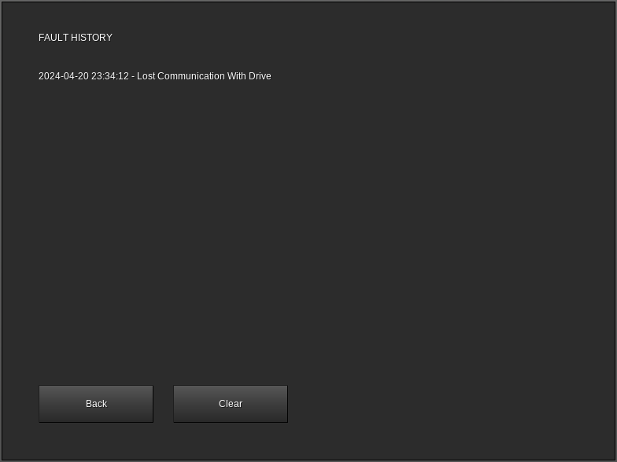
For information on a specific fault, see the Controller Messages section on page 32.
Back - Returns to the Car Status screen.
Clear - Removes all entries from the fault log.

Edit Parameters
Displays and enables editing of parameters, as well as offering options for recovering from certain problems:
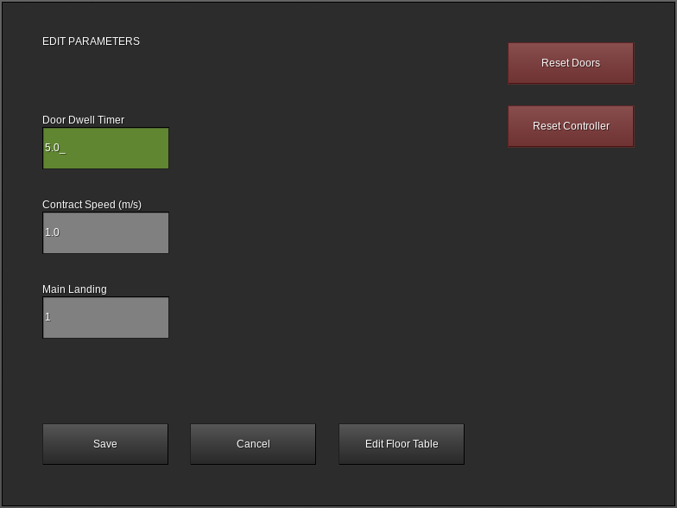
Door Dwell Timer - When in normal operation, the length of time the doors will stay open in response to a call before beginning to close.
Contract Speed - The maximum speed of the car in meters per second.
Main Landing - The landing number (not floor name) that the car will return to when fire service phase 1 is activated.
Save - Saves changes to the above three parameters and returns to the car status display.
Cancel - Returns to the car status display without saving any changes to the above three parameters.
Edit Floor Table - Available on simplex cars only. Allows for editing the list of floors served by the car. See the Configuring the controller floor table section on page 13.
Reset Doors - Attempts to resynchronize the state of the doors in the controller memory with the actual physical state of the doors. This can help with recovering from conditions where the doors were unable to open.
Reset Controller - Cancels all calls, immediately closes the doors, and causes the car to return to the lowest landing.

Dispatcher Interface

Group Display
This screen shows the status of all of the cars in the group:
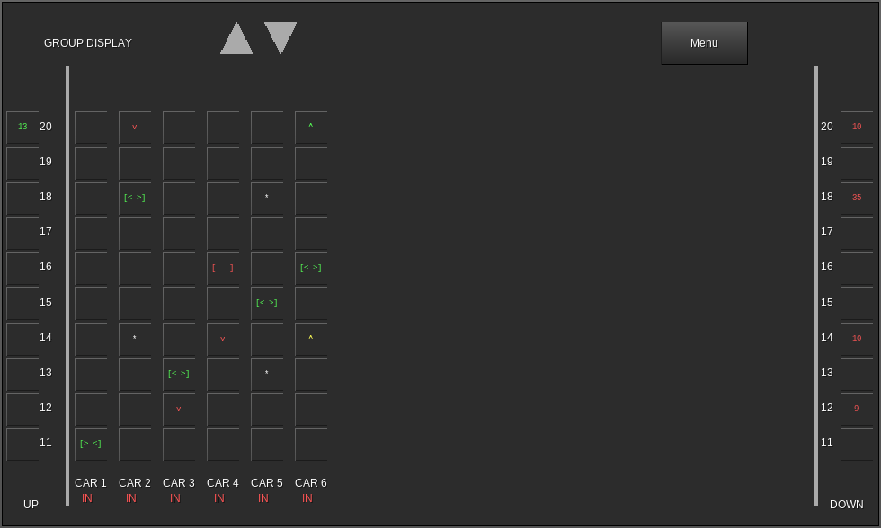
UP Column - At landings where an up hall call exists, shows a green number representing the estimated time (in seconds) until a car arrives to answer the call. Clicking in this column at one of the landings will place an up hall call at that landing.
DOWN Column - At landings where a down hall call exists, shows a red number representing the estimated time (in seconds) until a car arrives to answer the call. Clicking in this column at one of the landings will place a down hall call at that landing.
CAR Columns - Each column is labeled at the bottom to indicate which car in the group it corresponds to. Below the car number, IN is displayed if the car is in normal operation and able to receive calls from the dispatcher, or OUT if it is currently not participating in the group.
At each landing, five indicators can be displayed in each car column:
- Green Up Arrow - An up hall call exists at this landing and is currently assigned to this car.
- Red Down Arrow - A down hall call exists at this landing and is currently assigned to this car.
- Yellow Up Arrow - A swing up call (up hall call specific to this car) exists for this car at this landing.
- Yellow Down Arrow - A swing down call (down hall call specific to this car) exists for this car at this landing.
- White Asterisk - A car call exists for this car at this landing.
At the landing where the car is present, a symbol representing the car is displayed instead. The appearance of this symbol indicates the state of the doors as follows:
- [ | ] - Doors closed
- [< >] - Doors opening
- [> <] - Doors closing
- [ ] - Doors open
This symbol is also colored to represent the current collector state of the car. When the car is collecting up calls, the symbol is colored green. When the car is collecting down calls, the symbol is colored red. If the car is idle, the symbol is white. The color of the symbol may not reflect the actual travel direction of the car.
Menu - Shows the main menu screen.

Main Menu
Allows access to dispatcher configuration options:
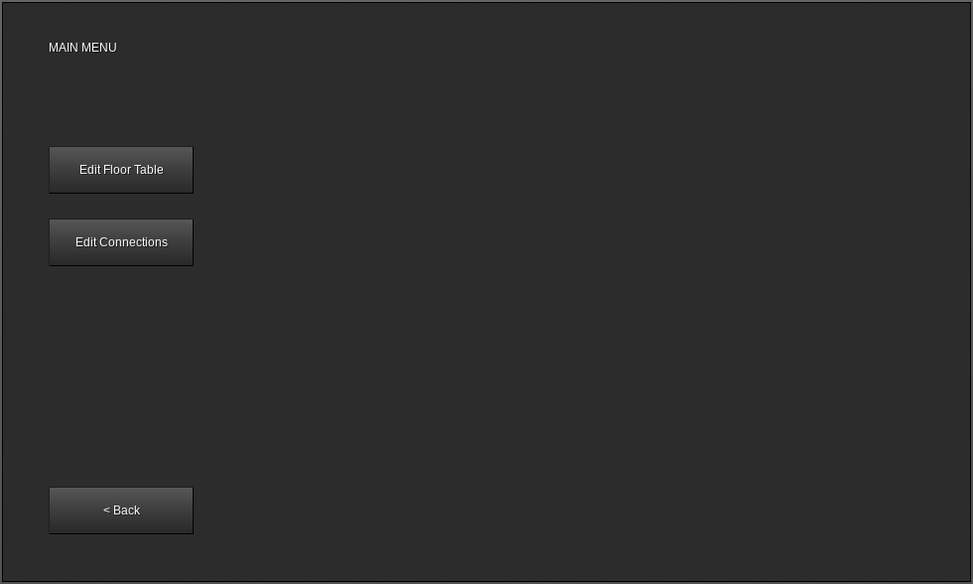
Back - Returns to the group display screen.
Edit Floor Table - Displays the edit floor table screen. See the Configuring the dispatcher floor table section on page 15. Hall calls are not accepted while this option is in use.
Edit Connections - Displays the edit connections screen. See the Connecting to the controllers section on page 18. Hall calls are not accepted while this option is in use.

Controller Messages

Message | Attempted to Move Doors With Car in Motion
Reason | Possible software issue.
Car Reaction | Car makes an emergency stop and all calls are canceled.
Troubleshooting | Contact manufacturer.

Message | Captured
Reason | Controller CAPTURE switch is in the on position and no further calls exist.
Car Reaction | Car remains at the last served floor with the doors closed. Hall calls are not accepted. Car calls are served normally.
Troubleshooting | Verify that the controller CAPTURE switch is in the off position.

Message | Car Top Inspection
Reason | INSPECT/RUN switch on the car top is in the INSPECT position.
Car Reaction | Car makes an emergency stop if running and cancels all calls. Once stopped, car can be moved at reduced speed in 1m increments using the car top UP and DN buttons.
Troubleshooting | Verify that the car top INSPECT/RUN switch is in the RUN position.

Message | Door Close Timeout
Reason | Door attempted to close, but did not reach the fully closed position within 10 seconds.
Car Reaction | All calls are canceled and the car is not allowed to run.
Troubleshooting | Remove and replace doors on the affected floor and try again.

Message | Door Open Timeout
Reason | Door attempted to open, but did not reach the fully open position within 10 seconds.
Car Reaction | All calls are canceled and the car is not allowed to run.
Troubleshooting | Remove and replace doors on the affected floor, push Reset Doors on the controller parameters page, and try again.

Message | Drive Metadata Load Failure
Reason | The drive attempted to load its metadata but was unable to load or parse it.
Car Reaction | All calls are canceled and the car is not allowed to run.
Troubleshooting | Remove and replace drive, hoist machine, and car.

Message | Drive Not Configured
Reason | The drive was unable to find its configuration information.
Car Reaction | All calls are canceled and the car is not allowed to run.
Troubleshooting | Punch the hoist machine. If this does not resolve the issue, remove and replace the car and hoist machine.

Message | Drive Origin Invalid
Reason | The drive was unable to parse its configuration information.
Car Reaction | All calls are canceled and the car is not allowed to run.
Troubleshooting | Punch the hoist machine. If this does not resolve the issue, remove and replace the car and hoist machine.

Message | Emergency Stop
Reason | Controller RUN/STOP switch is in the STOP position.
Car Reaction | Car makes an emergency stop if running and cancels all calls. Once stopped, car is not allowed to run.
Troubleshooting | Verify that the controller RUN/STOP switch is in the RUN position.

Message | Fault
Reason | Varies based on specific fault.
Car Reaction | Varies based on specific fault. In most cases, the car makes an emergency stop if running, cancels all calls, and is not allowed to run.
Troubleshooting | Click Fault History and follow instructions for the specific fault(s) displayed.

Message | Fire Service - Phase 1
Reason | Fire recall keyswitch was turned to the ON position.
Car Reaction | All calls are canceled and the car returns to the landing designated by the Main Landing parameter setting.
Troubleshooting | Turn the fire recall keyswitch to the RESET position, then OFF.

Message | Fire Service - Phase 2
Reason | In-car FIRE SVC keyswitch is in the ON position.
Car Reaction | All hall calls are canceled. Car responds to car calls, but doors do not operate automatically. Doors can be opened or closed using the door open and door close buttons. Call cancel button is operational.
Troubleshooting | Turn the in-car FIRE SVC keyswitch to the OFF position.

Message | Fire Service - Phase 2 Hold
Reason | In-car FIRE SVC switch is in the HOLD position.
Car Reaction | All calls are canceled. The car is not allowed to move and the door is not allowed to close.
Troubleshooting | Turn the in-car FIRE SVC keyswitch to the OFF position.

Message | Independent Service
Reason | In-car IND SVC switch is in the ON position.
Car Reaction | All hall calls are canceled. Car responds to car calls, but doors do not close automatically. Doors can be closed using the door close button. Call cancel button is operational.
Troubleshooting | Turn the in-car IND SVC switch to the OFF position.

Message | Inspection Conflict
Reason | Controller INSPECT/NORMAL and car top INSPECT/RUN switches are both in the INSPECT position at the same time.
Car Reaction | Car makes an emergency stop if running and cancels all calls. Car is not allowed to run.
Troubleshooting | Set the controller INSPECT/NORMAL switch to the NORMAL position or the car top INSPECT/RUN switch to the RUN position. Only one of these switches is allowed to be set to INSPECT at one time.

Message | Lost Communication With Drive
Reason | The controller was unable to communicate with the drive.
Car Reaction | All calls are canceled. The exact car motion behavior varies depending on the cause of the problem.
Troubleshooting | Remove and replace car, hoist motor, and drive.

Message | Machine Room Inspection
Reason | Controller INSPECT/NORMAL switch is in the INSPECT position.
Car Reaction | Car makes an emergency stop if running and cancels all calls. Car can be moved at reduced speed in 1m increments by using the controller UP and DOWN buttons.
Troubleshooting | Verify that the controller INSPECT/NORMAL switch is in the NORMAL position.

Message | Normal Operation
Reason | No faults are currently present in the controller memory and no special operation modes are active.
Car Reaction | None.
Troubleshooting | None.

Message | Position Sync - Floor
Reason | The car had previously stopped between floors due to an emergency stop or inspection operation and is now returning to the nearest floor.
Car Reaction | Car moves downward to the nearest floor.
Troubleshooting | Wait for the operation to complete.

Message | Position Sync - Terminal
Reason | The floor table was changed or the controller was reset. The car is now reestablishing its position by traveling to the lowest floor.
Car Reaction | Car moves downward to the lowest floor.
Troubleshooting | Wait for the operation to complete.

Message | Target Position Out of Bounds
Reason | The car attempted to move below the lowest floor or above the position of the hoist machine.
Car Reaction | All calls are canceled and the car is not allowed to run.
Troubleshooting | Verify that the floor table is correct and that the hoist machine is above the highest floor to be served. If the problem persists, remove and replace the car, drive, and hoist machine.

Message | Test Mode
Reason | The controller TEST switch is in the on position.
Car Reaction | All hall calls are canceled. Car responds to car calls, but doors do not open.
Troubleshooting | Verify that the controller TEST switch is in the off position.

Message | Uninitialized
Reason | Controller is missing setup information.
Car Reaction | All calls are canceled and the car is not allowed to run.
Troubleshooting | Replace controller.

